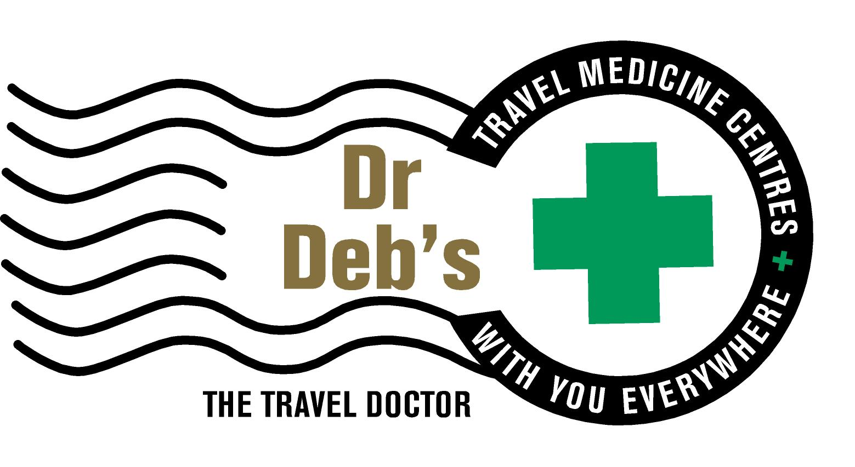

Dr Deborah Mills 185485T
GPO BOX 2832 Brisbane 4001
Ph 07 3221 9066 Fax 07 3221 7076
Email <clinic@thetraveldoctor.com.au>

Dear Bat Carer,

Please find enclosed the result of your most recent rabies antibody blood test and a ‘Rabies Antibody Reference Card’ for your wallet.

Your result shows that your rabies antibody level is currently above the recommended level. We recommend you have a repeat blood test in ____________ year/s to ensure these levels remain protective. Please note this in your diary as we do not provide reminders for the rabies antibody blood test.

Just a reminder, that in the event of a bite, scratch or lick on an open wound, you must immediately wash the area with soap and running water for 5 minutes. Do not Scrub. If possible, apply an iodine solution or 40-50% alcohol (whiskey or other spirit can be used. Seek medical advice to arrange two post exposure rabies vaccinations, on day one and day three.

Please phone our clinic if you have any queries. We wish you all the best regarding your work with Bats.

Yours sincerely,

Dr Deb - The Travel Doctor.

