Ms Kei Owada

Kei Owada (MPH) is a PhD candidate in infectious disease epidemiology at the University of Queensland, conducting research on the role of neglected tropical diseases, malnutrition and malaria on developmental morbidity in children in the Philippines and Africa. Before commencing her PhD, Kei received training in disease surveillance at the US CDC and worked as a WHO field epidemiologist in Sierra Leone in 2012, and worked as a research assistant with the Monash University School of Public Health and Preventive Medicine and the Eastern Health Clinical School from 2006 to 2011. In November 2014, Kei was deployed as a field epidemiologist to support the WHO's response to Ebola outbreak in Sierra Leone in collaboration with the local Ministry of Health and the US CDC. Her work involved epidemiological surveillance activities including active case investigations, contact tracing in identified Ebola hot spots, and coordination of outbreak data collection. Kei will share some of her experiences and photos from the field.

Professor Philip Weinstein

Professor Philip Weinstein is the Head of School of Biological Sciences at the University of Adelaide. He holds dual qualifications in ecology (PhD) and public health medicine (MBBS, FAFPHM). Phil has lectured zoology at James Cook University, was Professor of Public and Environmental Health at the University of Queensland, and Head of School of Population Health at the University of Western Australia. He has over 250 publications on the environmental determinants of water-borne and mosquito-borne disease, and also led a major research programme on air quality and respiratory health through the Cooperative Research Centre for Asthma and Airways. He was a member of the Board of Review Editors for the global Millennium Ecosystem Assessment, served as Co-Chair of the International Medical Geology Association, and is currently Vice President of the Australian Entomological Society.

Professor Alex Loukas

Director, Centre for Biodiscovery and Molecular Development of Therapeutics,
Australian Institute of Tropical Health and Medicine
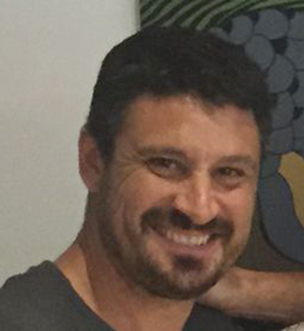
Alex Loukas is a Tropical Research Leader at JCU. He is an NHMRC Principal Research Fellow and editor-in-chief of the International Journal for Parasitology. He received his PhD from University of Queensland in 1995 and has since worked at The University of Edinburgh, George Washington University and Queensland Institute of Medical Research. His major research interest is the molecular basis of host-parasite interactions, with a particular focus on characterising the functions of proteins secreted by helminths (worms) that parasitise humans in developing countries. Research projects include: (1) development of vaccines for human hookworm disease and schistosomiasis; (2) molecular pathogenesis of infection with the carcinogenic liver fluke; (3) characterising the secretomes of parasitic helminths using proteomics; (4) human helminths as therapies for autoimmune and allergic diseases. His research is supported by international and national funding bodies including NHMRC (program and project grants), Unites States NIH and large pharma. He is the author of more than 200 peer-reviewed publications and has received numerous awards for his research.

